B. In-Depth Explanation & Analysis
1. Demographic Transition Theory: The Story of Progress Every country passes through stages.
- Stage I (Primitive): High Birth Rate + High Death Rate = Low Growth. (Why? No medicine = many die. Need many hands for farms = many born).
- Stage II (Developing): High Birth Rate + Falling Death Rate = Population EXPLOSION. (Why? Medicine improves, people live longer, but old habits of big families remain).
- Stage III (Developed): Low Birth Rate + Low Death Rate = Stable Low Growth. (Why? Urban lifestyle, education, women working = smaller families).
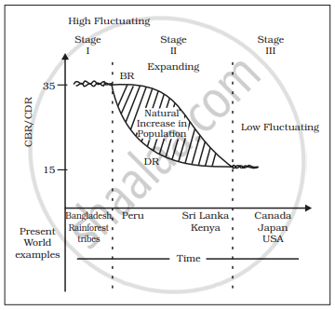

2. Migration: Push vs. Pull Factors People move for a reason.
- Push Factors: Things that force you to leave a place (unemployment, war, disasters, harsh climate).
- Pull Factors: Things that attract you to a new place (better jobs, peace, pleasant climate, city life).
- Analogy: A push factor is like a bully kicking you out of a room; a pull factor is like the smell of pizza inviting you into the kitchen.
3. Growth vs. Development (Chapter 3) Students often confuse these.
- Growth: Quantitative. Getting bigger. (e.g., A city's population grows from 1 million to 2 million. It grew, but did life get better? Maybe it just got crowded and dirty).
- Development: Qualitative. Getting better. (e.g., That same city builds hospitals, schools, and parks. Even if population stayed same, it developed).
- Tutor Tip: You can have growth without development (common in many poor countries), but true development always involves positive growth in quality of life.
Mentor’s insight:
  - Remember the formula to calculate the density of population (population divided by area), Crude birth/death rate (CBR = $\frac{B}{P}×1000$).
  - If a high weightage question is asked about demographic transition make sure to draw a properly labelled diagram.
  - Geographical factors (water availability, landforms etc.), Economic factors (minerals, urbanizations, industrialization) and social and cultural factors are important factors that influence the distribution of population.
  - Basic concepts like the differentiation between growth of population and natural growth of population are important, so prepare them thoroughly.
  - In the third chapter remembering the different approaches of human development (income approach, welfare approach, basic needs approach and capability approach (prof. Amartya Sen)). The human poverty index measures the shortfall in human development, it is often shows the wider reality.
  - Prof. Amartya Sen’s work explores that increasing freedom is one of the most effective ways to bring development.

